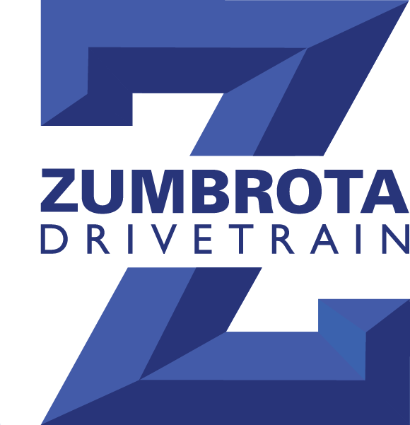
STANDARD
WARRANTY

IF WE BUILT IT, WE STAND BEHIND IT,
100% FOR TWO FULL YEARS

Zumbrota Drivetrain Inc. will replace or repair, any remanufactured
manual transmission, transfer case or differential for 2 years
from date of purchase FREE OF CHARGE, it’s that simple!

LABOR: All labor for installation must be done at a legitimate repair facility holding regular business hours and open to the general public. In order to pursue labor reimbursement a printed copy of the repair facilities repair order will be required. Hand written & non-business type repair orders are not accepted. Qualifying labor shall be reimbursed at a maximum of $150.00.

FREIGHT: The warranty will cover up to a maximum of $200.00 in freight charges.

LIMITATIONS AND EXCLUSIONS:
A. This warranty does not cover commercial, farm vehicles, motorhomes, rental, off road, high performance, etc.
B. Warranty coverage is VOID if vehicle has been altered or modified in any way from how the vehicle was originally equipped. Including but not limited to the following: tuners, EGR delete kits, exhaust, injectors, injection pump modifications, turbochargers, super chargers, performance clutches, and tire sizes that are different than what the vehicle was originally equipped with.
C. This warranty does not cover damage resulting from incorrect installation, tamper, abuse, low fluid level, incorrect fluid, unreasonable use, mistreatment, neglect, negligence, or accidental breakage.
D. Zumbrota Drivetrain Inc. will not be liable for death or injury to a person or damage to property; or any incidental or consequential damages resulting from the use of its products. Such damages include, but are not limited to damage to transmission, engine components or other associated parts, cost of capital, telephone, and freight charges, sales tax on any parts or repairs, or any customer claims of damages.

CUSTOMER/INSTALLER RESPONSIBILITIES:

Zumbrota Drivetrain Inc.’s installation guidelines must be strictly followed. Failure to follow proper installation procedures will void warranty.
*See installation tag attached to the unit. *
Proper maintenance as per vehicle manufacturer’s guidelines must be followed.

CLAIMS PROCEDURE:
A. In the event your vehicle needs repair, first contact Zumbrota Drivetrain Inc. When calling have all warranty information available to the Customer Service Representative.
B. Before repairs are made you must obtain proper authorization from Zumbrota Drivetrain Inc., any repairs made without prior authorization will be denied
C. All products must be returned to Zumbrota Drivetrain Inc. for inspection before any reimbursement will be issued.
D. The warranty registration must be signed, completed and returned to Zumbrota Drivetrain within 30 days of purchase or this warranty is voided.

GENERAL:
A. There is NO provision for rental car, towing, motel, meals, travel, etc.
B. This warranty is between the original purchaser and Zumbrota Drivetrain and is not transferable.
C. If Zumbrota Drivetrain should elect to replace your unit, the replacement unit shall be considered to be a repair and does not extend the warranty beyond that issued with the original unit.
D. The warranty does not cover fluid or any miscellaneous shop charges. The customer will be responsible for any such cost incurred, that are not covered by the warranty.
E. No claims will be honored if any outstanding money, any open cores, or defects or invoices are due to Zumbrota Drivetrain.

APPLICABLE LAW AND VENUE FOR LEGAL ACTION:
This limited warranty allocates the risks of product failure between Zumbrota Drivetrain Inc. and the original owner as authorized by uniform commercial code and the applicable laws. In event of any legal action to enforce the terms of the warranty, the customer agrees that the laws of the state of Minnesota shall govern such action, that the courts of the state of Minnesota shall have exclusive jurisdiction for such actions, and the venue shall be Goodhue County, Minnesota.

Invoice # _____________ Tag# ___________ Install Mileage _____________ Date _________
Registration Available Online!
Skip the Mail: www.ZumbrotaDrivetrain.com

Invoice # ______________________________ Install Date __________________________
Tag # _______________________________Unit Type _____________________________
Vin # _________________________________
Vehicle Make _______________________ Model ___________________ Year ___________
Install Mileage ______________________
Installers:
Name ______________________________________ Phone # _________________________
City _________________________________ State _____________________ Zip ________
- I have read and I understand the terms of the warranty.
Vehicle Owner’s Signature _______________________________________________________
Installer’s Signature __________________________________________________________

